Data Presentation

The plots below which I’ll refer to as Figure 1, Figure 2, and Figure 3 respectively are from a large amount of data taken. Figures 1 and 2 are just two examples of the 37 hysteresis loops recorded. Figure 3 shows Remnant vs Angle for all 37 hysteresis loops which were taken at 10 degree increments from 0 to 360 degrees; where the angle is defined a clockwise rotation of the sample.

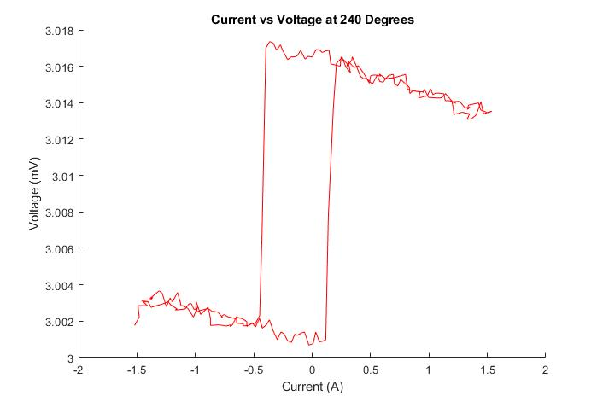

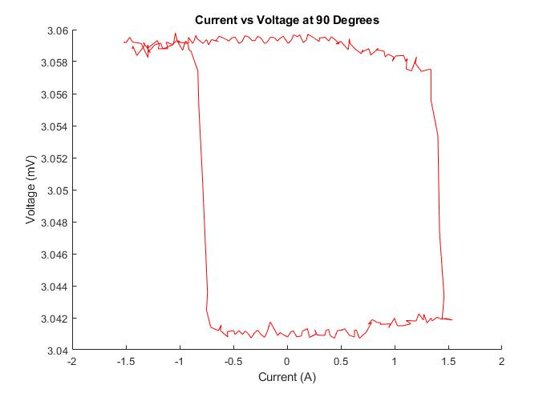

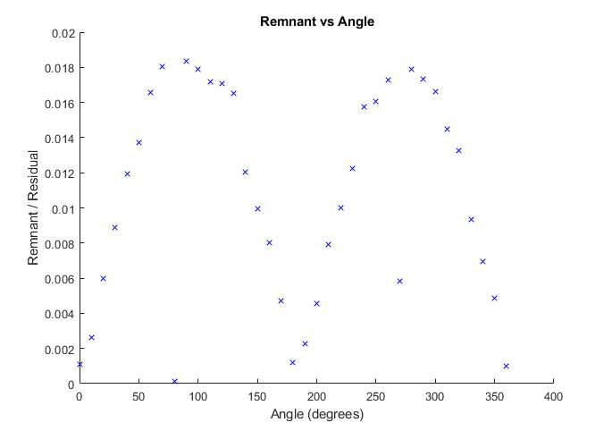

Analysis

There were no significant errors taking this data in this experiment. The action of rotating the sample create random errors in the data because angle that the sample is turned is based completely on the accuracy of the eye. But again, this did not significantly impact the data. There were also no large calculations needed for data manipulation. The data in the plots above were analyzed using MATLAB to organize and plot the data.

The first thing we noticed was a couple of patterns in the hysteresis loops as we turned the sample. At the angles 0 and 180 degrees we saw close to no residual magnetization; whereas at 90 and 270 degrees we saw the highest remnants (Figure 2, Figure 3). There was also a suspicious, sharp drop in residual magnetization at 90 and 270 degrees with unknown cause (Figure 3). We also saw the coercive field increase from 0 to 90, decrease from 90 to 180, increase from 180 to 270, and finally decrease again from 270 to 360. The hysteresis loops also began to invert at each 90-degree interval.

Conclusion

There was not a well-formed hypothesis for this experiment prior to taking data (other than perhaps that we had better see a hysteresis loop if this material is ferromagnetic), although there was plenty to learn about the properties of the sample and magnetization in general. The first point, and perhaps the most obvious, is that this material is highly anisotropic. This is easily seen at the coercivity and residual magnetization changed as we rotated the sample. This leads to a separation of the hard and easy axis. The hard axis of the material was aligned with the magnetic field at 90 and 270 degrees, and the easy axis aligned at 0 and 180 where it took the least amount of applied field (‘energy’) to reach saturation. This now leads to a plausible explanation as to why the hysteresis loops were inverting at 90-degree intervals; the hard and easy axes were perhaps being ‘flipped’.